**Mathematics Specialist Test 4 2018 Calculator Free Marking Key**

**Question 1(a)**

|  |
| --- |
| **Solution** |
| Then |
| **Specific behaviours** |
| 🗸 changes variable to *u* in integral  🗸 anti-differentiates with respect to *u*  🗸 evaluates correctly |

**Question 1 (b)**

|  |
| --- |
| **Solution** |
| Then    Hence    Thus the integral equals 1 if |
| **Specific behaviours** |
| 🗸 changes variable to *v* in integral  🗸 evaluates the integral correctly  🗸 deduces the correct value of *Q* |

2. (a) 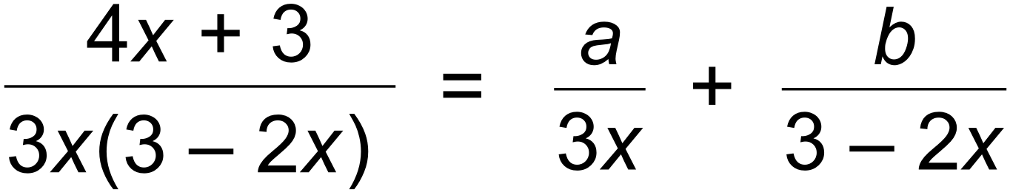 ✓

∴ 

∴  ✓

∴ 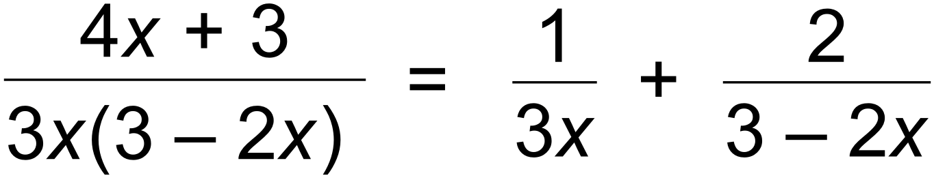 ✓

(b) 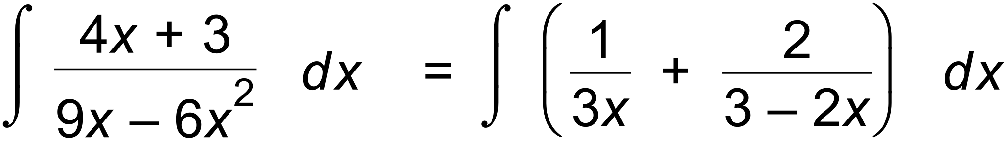 ✓

= 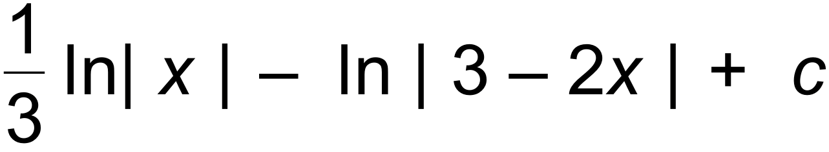 ✓✓ [6]

3. (a) 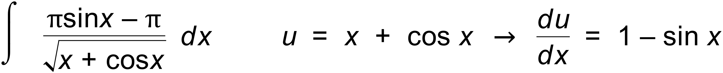 ✓

= 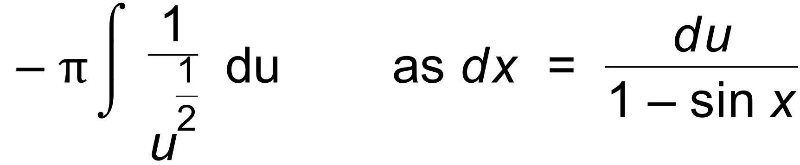 ✓

= 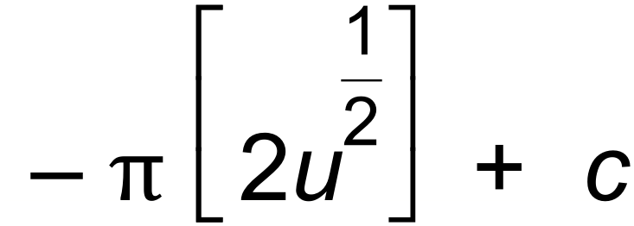 ✓

= 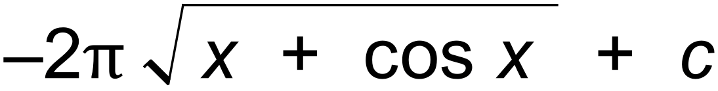 ✓

(b) 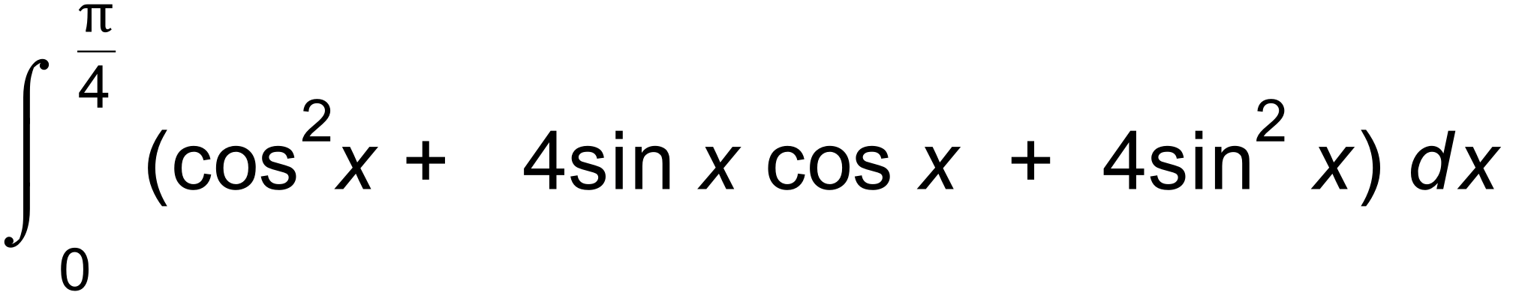 ✓

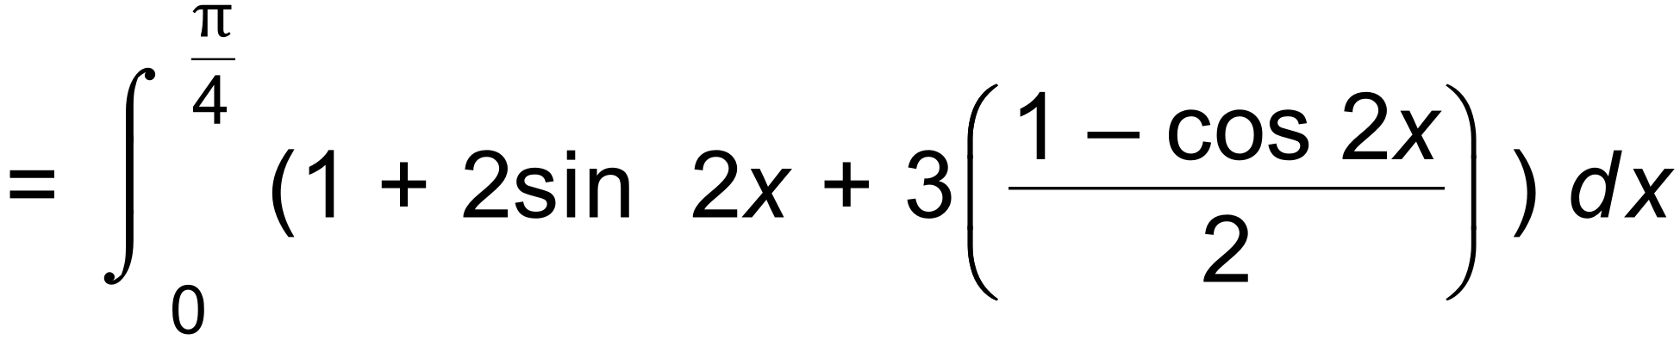 ✓

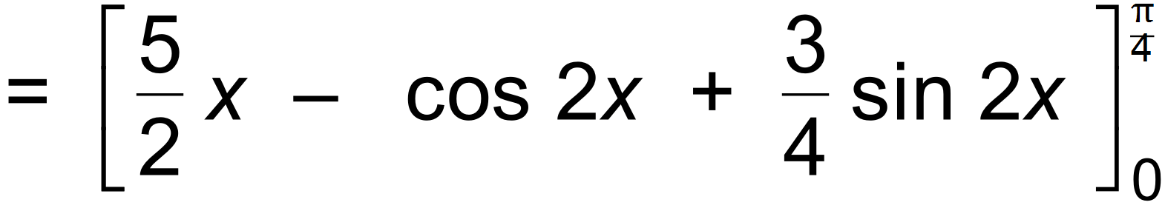 ✓

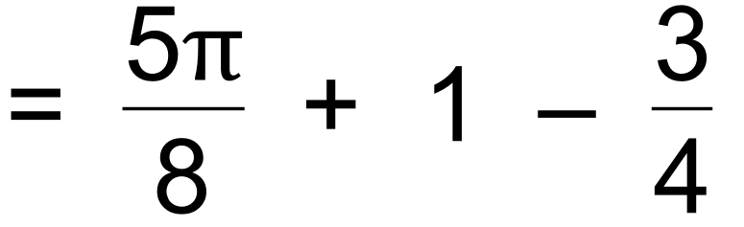

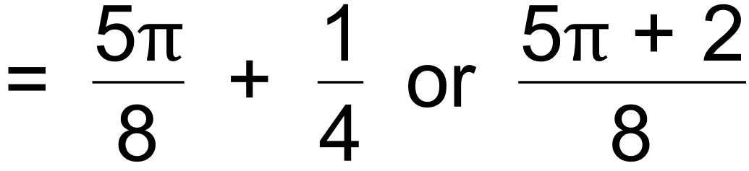 ✓ [8]

4. ✓

= ✓

= = ✓✓**MATHEMATICS SPECIALIST TEST 4 2018 MARKING KEY CALCULATOR ASSUMED**

Question 5 (5 marks)

Part of the graph of $y=3e^{\sin{\sqrt{x}}}$ is shown below.

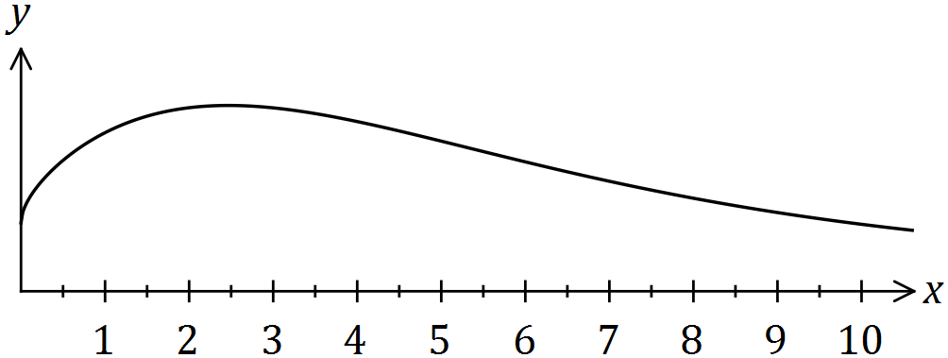

(a) Use numerical integration with three equal width trapeziums to estimate the area between the curve, the $x$-axis, the $y$-axis and the line $x=9$. (4 marks)

|  |
| --- |
| **Solution** |
| $$f\left(0\right)=3 \\ f\left(3\right)=8.0497 \\ f\left(6\right)=5.6790 \\ f\left(9\right)=3.4547$$ $$T\left(1\right)=\frac{3+8.0497}{2}×3=16.575 \\ T\left(2\right)=20.593 \\ T\left(3\right)=13.700$$ $$\text{Area}=50.87 \text{(4sf)}$$ |
| **Specific behaviours** |
| ✓ calculates $f\left(x\right)$ for  ✓ uses trapezium rule  ✓ area of one trapezium correct to at least 3rd decimal place  ✓ area rounded to 3 or more (ie 4, 5, ...) sf |

|  |
| --- |
| **Solution** |
| $$f\left(0\right)=3 \\ f\left(3\right)=8.0497 \\ f\left(6\right)=5.6790 \\ f\left(9\right)=3.4547$$ $$T\left(1\right)=\frac{3+8.0497}{2}×3=16.575 \\ T\left(2\right)=20.593 \\ T\left(3\right)=13.700$$ $$\text{Area}=50.87 \text{(4sf)}$$ |
| **Specific behaviours** |
| ✓ calculates $f\left(x\right)$ for  ✓ uses trapezium rule  ✓ area of one trapezium correct to at least 3rd decimal place  ✓ area rounded to 3 or more (ie 4, 5, ...) sf |

(b) Briefly explain how your estimate in (a) would change if thirty trapeziums were used.

(1 mark)

|  |
| --- |
| **Solution** |
| Estimate would increase. |
| **Specific behaviours** |
| ✓ indicates increase |

Question 6 (8 marks)

The velocity vector of a small body at time $t$ seconds is ms-1. Initially, the body has position vector $i-2j$.

(a) Determine the acceleration vector for the body when $t=\begin{matrix}2π \\ \overline{9}\end{matrix}$. (2 marks)

|  |
| --- |
| **Solution** |
| $$a\left(t\right)=6\cos{(3t)}i+12\sin{(3t)}j$$ $$a\left(\frac{2π}{9}\right)=(-3, 6\sqrt{3})$$ |
| **Specific behaviours** |
| ✓ acceleration vector  ✓ acceleration |

(b) Show that the maximum speed of the body is ms-1. (3 marks)

|  |
| --- |
| **Solution** |
| $$s^{2}=4\sin^{2}\left(3t\right)+16\cos^{2}\left(3t\right) \\ =4\sin^{2}\left(3t\right)+4\cos^{2}\left(3t\right)+12\cos^{2}\left(3t\right) \\ =4+12\cos^{2}{(3t)}$$ $$s^{2} \text{is max when} \cos^{2}{(3t)}=1$$ $$s_{max}=\sqrt{4+12}=4 \text{m/s}$$ |
| **Specific behaviours** |
| ✓ expression for $s$ or  ✓ simplifies expression  ✓ indicates maximum with justification |

(c) Determine the distance the body travels between $t=0$ and the first instant after this time that the body returns to its initial position, rounding your answer to the nearest cm.

(3 marks)

|  |
| --- |
| **Solution** |
| Period of motion is $\frac{2π}{3}$ $$d=\int_{0}^{\frac{2π}{3}}{\sqrt{4\sin^{2}\left(3t\right)+16\cos^{2}{(3t)}}}dt$$ $$d=6.46 \text{m}$$ |
| **Specific behaviours** |
| ✓ period  ✓ indicates valid integral  ✓ distance (*no rounding penalty*) |

Question 7 (8 marks)

The position vector of a boat motoring on a lake is given by $r\left(t\right)=4\sin{(2t)}i+(4-4\cos^{2}\left(t\right))j$, where $t$ is the time, in hours, after it leaves $(0, 0)$ and distances are in kilometres. The path of the boat is shown below, where the shoreline is represented by the line $y=0$.

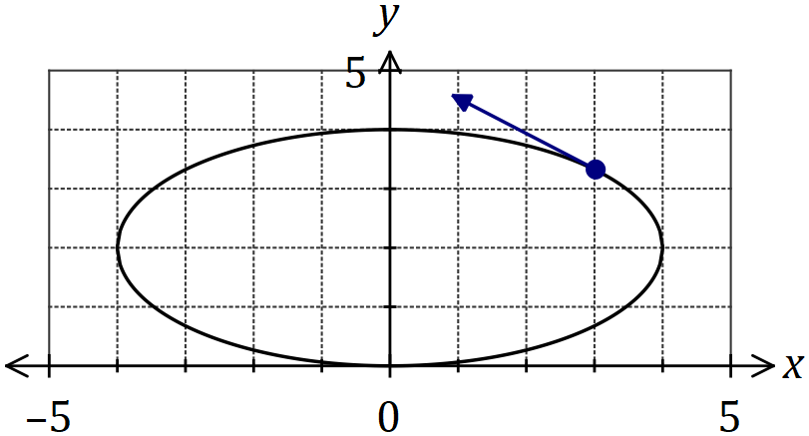

|  |
| --- |
| **Solution (b)** |
| See graph |
| **Specific behaviours** |
| ✓ position and direction |

(a) Express the path of the particle as a Cartesian equation. (3 marks)

|  |
| --- |
| **Solution** |
| $$4-4\cos^{2}\left(t\right)=2-2\cos\left(2t\right)$$ $$\frac{x}{4}=\sin{(2t)} \text{and }\frac{y-2}{-2}=\cos{(2t)}$$ $${\left(\frac{x}{4}\right)}^{2}+{\left(\frac{y-2}{2}\right)}^{2}=1$$ |
| **Specific behaviours** |
| ✓ uses double angle identity  ✓ isolates $\sin\left(2t\right)$ and  ✓ Cartesian equation |

(b) On the graph above, mark the position of the boat when it is first $3$ km from the shoreline and indicate the direction it is travelling. (1 mark)

(c) Determine the speed of the boat when it is first $3$ km from the shoreline. (4 marks)

|  |
| --- |
| **Solution** |
| $$4-4\cos^{2}\left(t\right)=3⇒t=\frac{π}{3}$$ $$v\left(t\right)=8\cos{(2t)}i+8\cos\left(t\right)sin⁡(t)j$$ $$v\left(\frac{π}{3}\right)=-4i+2\sqrt{3}j$$ $$s=2\sqrt{7}≈5.29 \text{km/h}$$ |
| **Specific behaviours** |
| ✓ determines time  ✓ obtains velocity vector  ✓ velocity vector at time  ✓ speed |

Question 8 (5 marks)

Part of the graph of $y=6\sin{3x}$ is shown below.

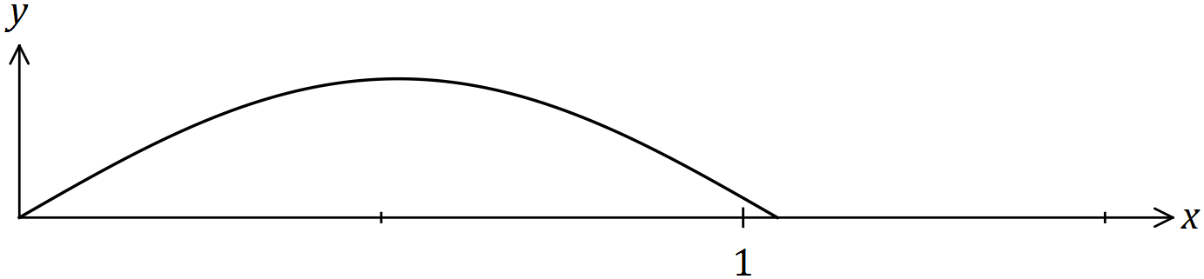

Show that when the part of the curve between $x=0$ and $x=\frac{π}{6}$ is rotated about the $x$ axis, the volume of the solid generated is $3π^{2}$. Clearly indicate all trigonometric identities used.

|  |
| --- |
| **Solution** |
| $$V=π\int_{0}^{\frac{π}{6}}{6^{2}\sin^{2}{3x}}dx$$ $$\sin^{2}{3x}=\frac{1}{2}(1-\cos{6x})$$ $$36\sin^{2}{3x}=18\left(1-\cos{6x}\right) \\ =18-18\cos{6x}$$ $$V=π\int_{0}^{\frac{π}{6}}{18-18\cos{6x}}dx \\ ={π\left[18x-3\sin{6x}\right]}_{0}^{\frac{π}{6}} \\ =π\left(3π-0\right)-π(0-0) \\ =3π^{2}$$ |
| **Specific behaviours** |
| ✓ writes correct integral to evaluate  ✓ shows identity for  ✓ substitutes to obtain expression in terms of  ✓ integrates correctly  ✓ substitutes all limits (and simplifies) |